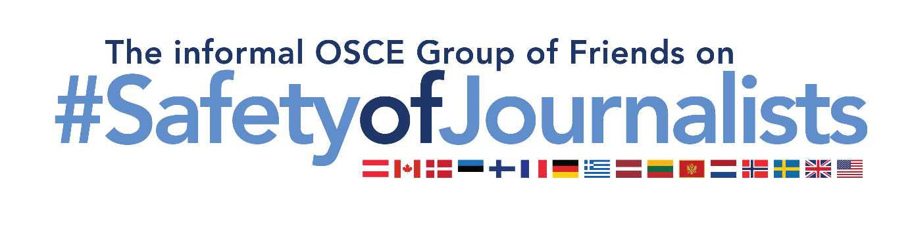
Group of Friends on Safety of Journalists’ statement at the 1st Supplementary Human Dimension Meeting on Media Freedom as a Central Pillar of Comprehensive Security
Vienna, 13-14 March 2023

SESSION I: Why there can be no comprehensive security without media freedom

Mr Chair,

I take the floor on behalf of the informal OSCE Group of Friends on Safety of Journalists, namely Austria, Canada, Denmark, Estonia, Finland, France, Germany, Greece, Latvia, Lithuania, Montenegro, the Netherlands, Norway, Sweden, the United Kingdom, and the United States.
We would like to thank the Chairpersonship of North Macedonia, RFoM and ODIHR for drawing attention to the important linkage between media freedom and security. We would also like to thank the guest speakers for their presentations, and all the journalists and independent civil society representatives for their crucial contributions to advance media freedom in the OSCE region.
Many states from our Group of Friends on Safety of Journalists host journalists and other media actors fleeing persecution and war. Some also host independent media outlets, mostly from Russia and Belarus, but also from other participating States from the OSCE region and its neighbouring countries, such as Afghanistan, who have been forced to move their whole businesses and start anew in exile. iStories, meduza.io, Novaya Gazeta Europe, OVD Info, Mediazona, Newsader, TV Rain, to name just a few of the media outlets that continue their work abroad after having been pushed out of their countries.
While many challenges remain, our governments and various national stakeholders aim to contribute to facilitate relocation and a safe environment to enable media outlets, journalists and other media workers to continue their journalistic work in exile:
- Many of our governments provide visa assistance for journalists and their family members, including through the issuance of humanitarian visas. One country is preparing national legislation regarding humanitarian visas to be issued to human rights defenders in need of immediate or temporary protection.
- Various countries are facilitating journalists in receiving residence and work permits allowing for their easier integration.
- Many of our governments cooperate with and fund international, regional and national non-governmental organizations (NGOs) that support journalists living in exile through different programmes and initiatives. With the help of NGOs and international organizations, journalists and media actors are provided with safe housing, emergency funds, equipment, as well as legal and other assistance. We recognize the importance to adopt a gender-responsive approach in this regard, in view of the distinct risks and challenges faced by women journalists in relation to their work.
- In several countries, pilot programmes and other initiatives to offer protection and support to journalists who are under threat for the conduct of their important work have been launched. These pilot projects include training, technical support to facilitate broadcasting from abroad, job offers in local media outlets, regional scholarship and fellowship programmes, as well as exile journalism centers in countries abroad and corresponding measures for journalists living in exile.
We thank the RFoM for her leadership in promoting safety of journalists. We especially appreciate the series of roundtable discussions aimed at sharing recommendations with participating States on measures to ensure better protection for journalists and media actors. The roundtable on safety of journalists in conflict situations gave us a most valuable opportunity to discuss challenges faced by journalists in exile. We call on participating States to implement recommended measures that allow journalists to continue to carry out their important work while working in exile, as we will strive to do ourselves.

I thank you.

