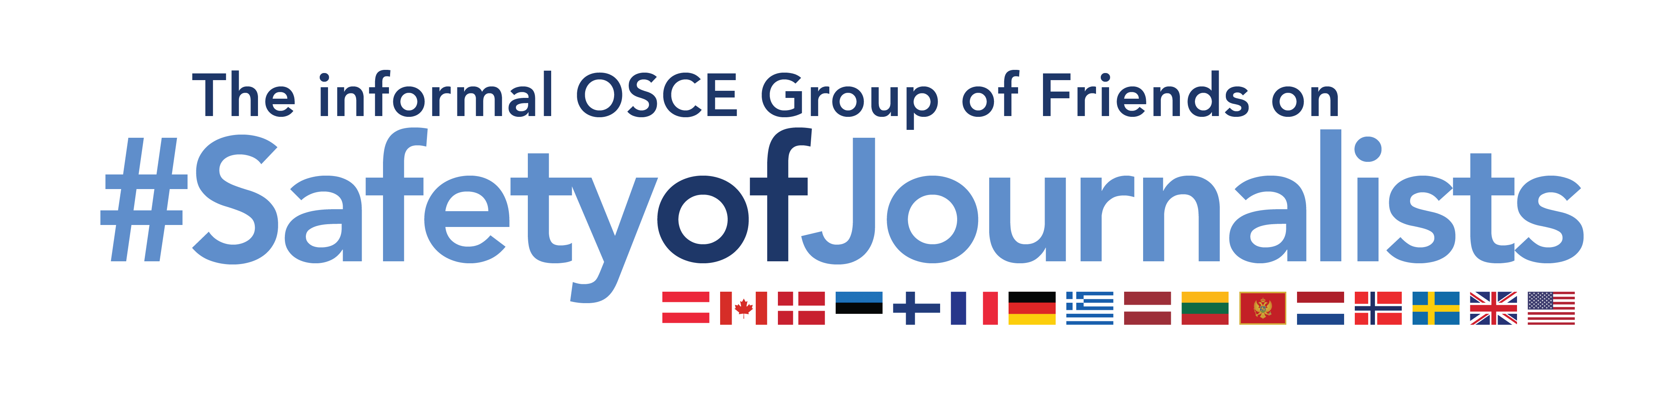
Group of Friends on Safety of Journalists’ statement
at the Human Dimension Committee Meeting
on Freedom of the Media and Safety of Journalists, Vienna, 22 February 2022

Madam Chair,

I take the floor on behalf of the informal OSCE Group of Friends on Safety of Journalists, namely Austria, Canada, Denmark, Estonia, Finland, France, Germany, Greece, Latvia, Lithuania, Montenegro, the Netherlands, Norway, Sweden, the United Kingdom, and the United States.

We would like to thank the Norwegian Chair of the HDC and the Polish CiO for raising the topic of this meeting, particularly for drawing attention to the link between disinformation and misinformation and the safety of journalists, online as well as offline. We would also like to thank both speakers for their presentations.

Your presentations have underlined how new technologies and our increased online presence, not least during the Covid-19 pandemic, continue to impose new challenges to the safety of journalists. As OSCE countries, we must respond to these challenges in accordance with our commitments.

Today, journalists are faced with various complexities. On the one hand, dis- and misinformation as well as distortion of facts fuelled by both state and non-state actors is rapidly spreading, especially on social media. On the other hand, independent, trustworthy media is increasingly discredited or rejected, even by some public authorities, as being politically motivated or simply “fake news”, thereby challenging the reputation and safety of journalists and other media actors.

The threat is real. As we have heard, verbal attacks, discrediting of and outright crimes against journalists – especially women journalists – are multiplying in digital communications. And according to a recent survey by UNESCO and the International Centre for Journalists, online threats are increasingly associated with physical attacks.

That is why the work done by the RFoM and her Office on safety of journalists is crucial. The Resource Guide on the Safety of Female Journalists Online is full of useful recommendations to tackle many of the issues we have heard presented today. Now, it is up to us as participating States to find ways to implement the recommendations and to increase trust in the media as a whole in close partnership with civil society, journalists, media outlets, other media actors, and online platforms.

- Various states from our Group of Friends on Safety of Journalists have, or are in the process of developing, national action plans on safety of journalists; and we thank Switzerland and others for sharing with us their best practices in this regard.

- Furthermore, various states from the group have created specialised units at public prosecutors’ offices to investigate and prosecute online crimes and those with an online nexus, given the specific technical challenges in this field of law enforcement. The tightening of anti-stalking laws and the introduction of stricter sentences for certain crimes endangering the safety of journalists are other measures applied by some members of the group to protect women journalists and others. The fight against impunity for crimes committed against journalists plays a key role to ensure journalists’ safety, as highlighted in the 2018 Milan decision.

- With the assistance of public funds, non-governmental organisations such as Reporters Without Borders have taken interesting initiatives to address, inter alia, the structural technological changes and their impact on global communication and information space. This includes the Forum on Information & Democracy and the Journalism Trust Initiative.

- At the same time, various campaigns have been created to raise public awareness and to strengthen civic resilience against disinformation and misinformation. In one member state of our group a tool has been created to expose fake news by uniting the state, civil society, and media in a joint fight against disinformation.

- Another group member funds specifically tailored training lessons for women journalists and media outlets on preventing and responding to online and offline harassment as part of a larger global programme focused on addressing violence against women in politics and the media.
We also appreciate the efforts by the Council of Europe and the European Union. We thank the RFoM for her leadership in promoting the Safety of Journalists, including women journalists, and stand ready to promote the best practices presented today in our respective participating States.

Joint declaration by The United Nations (UN) Special Rapporteur on Freedom of Opinion and Expression, the Organization for Security and Co-operation in Europe (OSCE) Representative on Freedom of the Media, the Organization of American States (OAS) Special Rapporteur on Freedom of Expression and the African Commission on Human and Peoples’ Rights (ACHPR) Special Rapporteur on Freedom of Expression and Access to Information on Freedom of Expression and “Fake News”, Disinformation and Propaganda, 3 March 2017.

