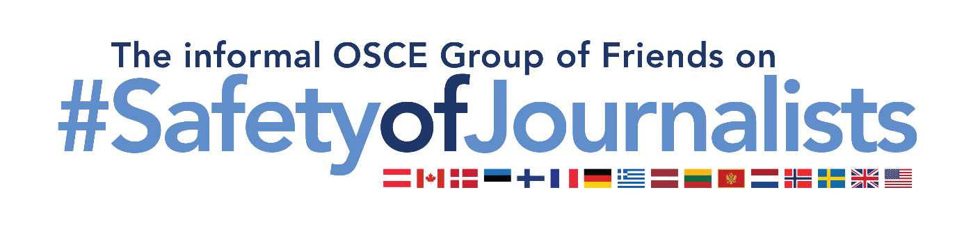
Joint Statement of the informal OSCE Group of Friends on Safety of Journalists
on World Press Freedom Day
As delivered by Ambassador Anne-Kirsti Karlsen at the Permanent Council
Vienna, 4 May 2023

Mr. Chair,
I am delivering this statement on behalf of the informal Group of Friends on Safety of Journalists, which consists of the following participating States: Austria, Canada, Denmark, Estonia, Finland, France, Germany, Greece, Latvia, Lithuania, Montenegro, the Netherlands, Norway, Sweden, the United Kingdom, and the United States of America. Yesterday, 3rd May, we celebrated the 30th anniversary of World Press Freedom Day. Three decades ago, the members of the UN decided to devote a day to the importance of press freedom. This day we commemorate the bravery of journalists, and other media actors who strive to uncover the truth. For 30 years, this day has also served as a reminder to governments of the need to respect their commitment to press freedom, and to do their utmost to ensure the safety of journalists and media actors.
However, the issue of safety of journalists is more pressing than ever. Russia’s full-scale invasion of Ukraine has imperiled journalists throughout the region. It has led directly to the deaths of journalists, uncovering atrocities and countering disinformation, related to Russia’s war of aggression against Ukraine.
The Kremlin's drastic censorship and suppression of media freedom also enables relentless state-sponsored disinformation about its war of aggression against Ukraine. It is spread virtually unchallenged to the public in Russia. We condemn the Russian Federation’s actions to silence journalists and other media actors, including the detention of Russian and foreign journalists. These actions are part of what the Representative on Freedom of the Media (RFoM) has rightly qualified as: “one of the worst declines in media freedom” since the creation of her mandate. We urgently call on Russia to immediately end its attacks on independent media, at home and abroad. We also call on Russia to release all those detained under spurious charges for exercising their rights, and freedom of expression. Access to factual and up-to-date information is always necessary for citizens to make informed choices, but it becomes essential in times of war and uncertainty.
Mr. Chair,
We are witnessing a worrying rise in abuse online, with a disproportionate targeting of women journalists, with harassment, threats, and reprisals. Online attacks have a chilling effect on women’s participation in the media, and in society. We must ensure a safe environment for all journalists and media actors, both online and offline.
Journalists play a crucial role in holding governments and institutions to account, while informing the public about matters of public interest. It is crucial that journalists are able to work independently, and without fear of harassment, intimidation or persecution. When peace and security come under threat, so does media freedom and democracy. And when media freedom and democracy are threatened, so is peace and security.
Mr. Chair,
As participating States of the OSCE, we have all affirmed and reaffirmed that freedom of expression and media freedom are cornerstones of our common security. To protect the safety of journalists is to protect the freedom of expression and media freedom. We call on all participating States, to take the necessary steps to implement our OSCE commitments on media freedom, and safety of journalists.

Thank you

